INDEX
INDEX
S.No | TOPIC | PAGE
1 | INTRODUCTION
 | 1.1 FLOW SYSTEM
 | 1.2 PERFORMANCE PARAMETERS FACILITIES
2 | DE-DUSTING SYSTEM START-UP PROCEDURE
 | 2.1 Pre-Start Check list for Centrifugal fan
 | 2.2 Pre-Start Check list for Bag Filter Pulsing System
3 | MODES OF OPERATION
 | 3.1 Time based puffing operation
 | 3.2 Pressure based puffing operation
 | 3.3 Discharge System
4 | HMI INTERFACE
 | 4.1 Auto mode controlling parameters
 | 4.2 Alarm points
5 | METHODOLOGY OF BAG FILTERS PUFFING
 | 5.1 Auto Puffing
 | 5.2 Manual Puffing
6 | Silos Dust Discharge System Operating Sequence in Manual mode
7 | Collecting Dust Hopper Discharge System Operation
8 | Area wise Suction Hoods and their Nomenclature
BF Process Flow:
Coke
Sintered Ore
Lump Ore
Mixed Ore
Bin
Bin
Bin
Bin
Vibrating screen & Weighing hopper

Vibrating screen &Weighing hopper

Vibrating screen & Weighing hopper

Feeder &
Weighing hopper

Coke breeze
Vibrating screen

Coke breeze bin

Main charging belt conveyor

Nut coke bin

Return ore belt
Ore fine bin
Ore Belt Conveyor
Bell-less Top charging equipment

450m³ BF
Bag filter
Gas pipeline
Clean gas
Truck
Gas Ash
Sintering Shop
Hot blast stove
Combustion air
Stack
BF blast blower

Gas Ash
BF main control room

HM
Granulated slag

Granulated slag shop

Truck
Pressure regulating valve manifold

PCI Station
Gravity dust catcher

Truck

Sintering shop

Truck
Raw Material Yard

Weighing hopper
Pig casting shop

Material Balance Chart:

Coke
20.0 ×10⁴ t/a

Sintered ore
62.88×10⁴ t/a
Lump ore
13.0×10⁴ t/a
Pulverized coal
4.5 ×10⁴t/a

450m³ BF
37.5 ×10⁴t/a hot metal

Granulated slag 17.25×10⁴t/a

Pig casting machine
37.5×10⁴t/a

Return Coke
1.25 ×10⁴ t/a

Return Fines
6.2 ×10⁴ t/a
1.25 ×10⁴ t/a

18×10⁴ t/a
Nut coke 0.75×10⁴ t/a吨/年

56.06×10⁴ t/a
Furnace Ash
0.46×10⁴t/a
BF Gas
100000～
120000Nm³/h

Main Technical Equipment of BF
1. STOCK HOUSE AND DE-DUSTING SYSTEM
1.0 Stock House
Introduction:
The raw material used For BF operation such as sintered ore, Lump ore, Coke, etc, will be conveyed from Sinter Plant and raw material yard by belt conveyor, via transfer station and screening room to BF stock house; then these materials will be discharged into its respective bins by dump car.
BF stock house system includes 4 coke bins, the effective volume of each bin is 120 m³; total 480 m³; 6 sinter bins, the effective volume of each bin is 95.5 m3; total 573 m3; 4 lump ore bins, the effective volume of each bin is 74.8 m3; total 299.2 m3; 4 miscellaneous bins, the effective volume of each bin is 79.7 m3; total 318.8 m3: there are 6 belts under the bin as mentioned below:
1 main belt for BF Top
1 main belt for ore and coke conveying
1 belt for return fines
1 belt for return coke
1 large angle belt for return ﬁnes
1 large angle belt for coke fines,
Sintered ore return ﬁnes bin, breezed coke & nut coke bin will be provided in return fines part. The return coke will he transferred into the breezed coke & nut coke bin after screened by the vibrating screen and the nut coke will be transferred to 1# main belt conveyor through 2# belt conveyor after weighed by receiving machine under the bin and weighing hopper, then into the blast furnace. In this way the amount of return coke will be reduced and utilization ratio of coke will be increased.
Gate valve, vibrating screen, feeder and weighing hopper are installed for all bins in the stock house.

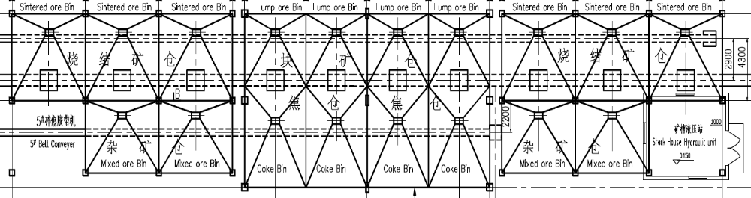
General layout of Stock House
Storage Capacity of Stock House System
Raw Material/Fuel | Consumption per hour (t) |  | Total Effective Volume(m³) | Storage Amount  （t） | Storage Time  （h） | Remarks
Coke | 0.48t/t | 21.60 | 480 | ～ 240 | ～ 11 | 0.5t/m³
Sintered Ore | 1.509t/t | 67.905 | 573 | ～ 945 | ～ 14 | 1.65t/m³
Lump Ore | 0.313t/t | 14.085 | 299.2 | ～ 658 | ～ 46.7 | 2.2t/m³
Miscellaneous Ore | 0.04t/t | 1.8 | 318.8 | ～542 | ～ 291 | 1.7t/m³

Sinter, lump ore, miscellaneous ore will be conveyed from under bin weighing hopper via ore (coke) main belt to the top charging main belt, then conveyed to BF top by the top feeding main belt conveyor. Return sinter + ore fines and return coke fines will be conveyed by return fines belt conveyor and return coke belt conveyor as well as large angle belt conveyor to return ore and return coke bin, and the cracked ore and coke will be transported outside by trucks.
Ventilation and de-dusting system is provided in vibrating screens and all the transfer points.
Raw Material Handling System
Raw Material Handling System includes ore transporting system and coke transporting system. All the raw materials are either supplied by plant self or outsourced. Dust catchers are equipped at all receiving points (Underground bins, transfer station #5) to reduce the amount of dust generation. Centralized interlocking control system is provided in independent operating house.
Demand and Max. Consumption of Raw Material and Fuel
Name | Bulk Density | Grain Size  (mm) | Moisture  (%) | Annual Consumption  (10⁴t/a) | Daily  Consumption  (t/d)
Sintered Ore | 1.65 | 5-50 | <5 | 71.32 | 2038
Lump Ore | 2.2 | 10-40 | <5 | 14.77 | 422
Coke | 0.5 | 10-60 | <5 | 22.68 | 648
Sundry Ore | 1.6 |  | <5 | 1.89

Process of transporting system
The sinter and lump ore are transported by this system; the capacity is 350t/h. The system adopts an 800mm belt conveyor.
Process flow is as follows:
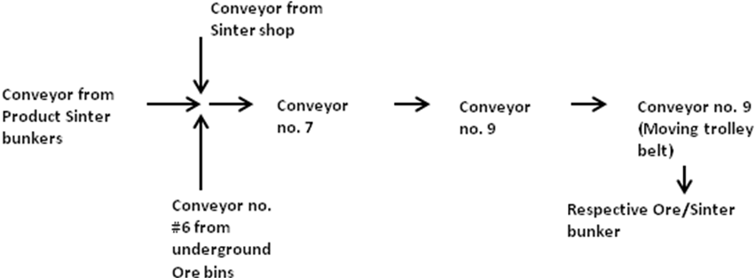
The coke and fluxes are transported by another system; capacity of this system is 100t/h. This also has 800mm belt conveyors.
Process flow is as follows:
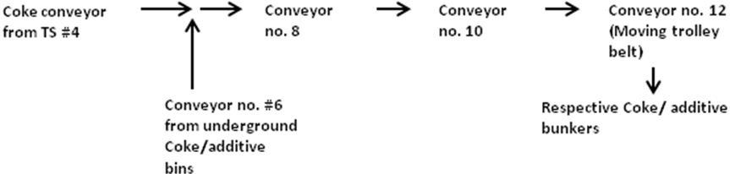
Main charging conveyor to BLT (Conveyor #1) is a 1000mm wide dual drive closed gallery belt system. The other collecting conveyor (Conveyor #2) is also a dual drive 1000mm belt system.
Equipment specification in stock yard:
Name | Type & Specification | Quantity | Unit Weight(Kg) | Remarks
Manual Bulkhead Gate | SPVd-50 | 6
Electric Vibration Feeder | ZG-100-300F | 6
Belt Conveyer | B=800mm | ～1400m
Discharging Car | B=800mm | 2 |  | With dust catcher

2.0 Bell-Less Top and Charging System
Introduction
Bell-less top charging equipment used is serial type. The BF top system has the advantages of good flexibility of burden distribution, good seal, be able to increase the pressure of BF top, therefore high-pressure operation will be realized.
Design Parameters
Effective Volume of BF 450m3
Diameter of furnace throat 4400mm
Utilization coefficient 2.4 t/m³.d
Output of pig iron per day 1080 t/d
Operating BF Top pressure 0.03 – 0.12 MPa
Temperature of BF Top:
Normal <250⁰C
Max 500⁰C (short time)

2.1 Basic distribution method and charging system of BF top
Each distribution methods are realized on the cross section of furnace throat to distribute the burden reasonably through the distributing device which will rotate and tilt the distributing chute and the flow regulation valve which will control the opening.
i. Distribution system
- Ring Distribution
The raw material in the bucket will consist of a concentric ring (single ring) or multiple concentric rings (multiple rings) through the distributing chute.
Single ring distribution: during the distribution of burden into the furnace, the distributing chute will keep a preset obliquity all the time.
Multiple rings distribution: during this distribution, the obliquity will be changed several times. One ring or several rings will be distributed in each obliquity, and the raw material will be distributed outer to inner (based on BF vertical central line). After one bucket finished filling, the chute will stop at its maximum obliquity automatically.
- Screw distribution
During the distribution, started at the preset obliquity, the chute will evenly distribute the burden along with the designed screw into the furnace and change into preset obliquity (a) in turn following the preset program.
- Section distribution
Taking the preset obliquity (a) position and selected plane angle or azimuth angle (B) as starting axis, the distributing chute will swing and distribute burden within the selected amplitude.
- Point distribution
The distributing chute will distribute the burden into any point in the furnace at the preset plane angle or azimuth angle (B) and obliquity (a).
Ring and screw distribution will be operated automatically, and the section and point distribution will be operated manually.
The ring distribution will be the basic distributing method of bell-less top equipment.
ii. Charging system
The basic charging system includes:
O C or C O
O stands for a batch of ore
C stands for a batch of coke
Stands for: the lower seal valve and throttle valve will be operated and distribute to the furnace through distributing chute.

2.2 Pressure Equalization and Bleeding System
Semi clean gas will be used for the first pressure equalization of bucket, and the diameter of hydraulic drive equalizer valve is 200mm. considering the pressure difference between furnace top and bucket(Burden tank) may be higher than 0.01 MPa after first equalization, in order to make sure the lower seal valve can be opened, nitrogen will be used for second pressure equalization. The nominal diameter of second equalizer valve is 80mm. the valve is motorized.
Bleed valve will be provided on the bucket. Bleeding operation must be conducted before opening the upper seal valve. The diameter of equalizer bleed valve is 300mm and bleed valve is hydraulic drove.
2.3 Stock rod
Two sets of 0-5m vertical stock rod and one set of radar level indicator will be installed at the furnace top. The lifting speed of stock rod is 0.802 m/s.
There are two working system of stock rod.
Basic working system
Under the normal condition, the stock rod will measure the level automatically and continuously. The stock rod will descend along with level and rise after reaching the stipulated level.

2.4 Maintenance Equipment on Furnace Top
1) 2sets of 10t monorail electric hoist will be provided at the top of furnace. the chain hoists will be used for maintenance of furnace top equipment, including the overall lifting of distributing chute and distributing device.
2) Under the valve box of lower seal valve, along the crane direction two lifting girders of interval 2800mm will be provided, on which 2 sets of 5t monorail electric hoist will be installed for handling the distributing device from the central line of BF. When changing the distributing device, the valve box of lower seal valve along with the throttle will be pushed back. The hooks of both sides will lift the distributing device and move it to the edge of platform on furnace top. Then the chain hoist on the furnace top will lift the distributing device on the ground. The installation of new distributing device will follow the reverse procedures.
3) One set of 3t electric hoist will be installed above the bleed valve on the furnace top. The equipment on furnace top such as gas bleed valve will be lifted on the furnace top platform.
2.5 Hydraulic Station and lubrication station
The furnace top hydraulic station, accumulator group and hydraulic valve station, which will be used for the transmission and control of BF top charging system, pressure equalizing and bleeding equipment.
Main Performance of Bell-Less Top Charging Equipment
No | Item Description | Qty. | Main Technical Performance | Drive | Remarks
1 | Receiving hopper | 1 | Vu=16m³
2 | Discharging valve | 1 | Diameter of Valve Port φ650mm | Hydraulic
3 | Upper sealing valve | 1 | Caliber φ700 mm  Rotation Angle100° | Hydraulic
4 | Bucket | 1 | Vu=16m³
5 | Throttling valve | 1 | Diameter of Valve Port 550 × 550 mm (max.) | Motorized
6 | Expansion joint |  | Compensation Rate：~15mm
7 | Lower sealing valve | 1 | Dia. φ600 mm  Rotation Angle 100° | Hydraulic
8 | Distributing device | 1 | Rotary Speed: 3-8 rpm  Tilting Speed 0.163~1.63°/s | Motorized rotation, Motorized tilting | ∠α：5-40°  Diameter of Throat:550mm
9 | Chute | 1 | L=1600mm

2.6 BLT Charging system sequence :
a. MATERIAL DISCHARGE FROM BURDEN TANK TO FURNACE
1. After sensing the set stock rod level 1800mm, Stock rod moves to its parking position.
2. Equalising of pressure between Furnace top and burden tank is done by Primary and Secondary equalising valves. Pressure equalising through primary & Secondary equalising valves will be done by BFG coming from the raw gas line for former and by Nitrogen gas for later one.
3. Lower seal valve opens completely.
4. BFRV opens(intermediate) to pre-set angle and for a pre-set time. The material from burden tank is charged into the furnace.
5. Distribution of material (Ore/Coke) while charging inside the furnace is done at given Chute, BFRV and Distributor angles.
6. BFRV opens completely to ensure 100% discharge of material and then Closes completely.
7. Lower seal valve closes completely.
b. MATERIAL DISCHARGE FROM RECEIVING TANK TO BURDEN TANK
1. Initially material in the receiving tank is received from the main charging conveyor as per the charging/batching sequence.
2. Relief valve opens to release the pressure stored in the Burden tank and closes completely.
3. Upper seal valve opens.
4. Burden stop valve opens completely for pre-set time and the material from the receiving tank is completely transferred into the burden tank.
5. Burden stop valve closes completely.
6. Upper seal valve closes completely.
2.7 Basic Important pre-set values to be maintained at BF Top
- Ensure Nitrogen gas pressure at BF top should be maintained at a minimum of 3.5 kg/cm².
- Top gas temperatures are to be maintained below 270⁰C ( High set temperature). If temperatures reaches above 270⁰C, ensure top water spray valve opens and closes after reaching the lower set temperature.
- Incoming water pressure for the distributor to be maintained above 5hg/cm², and flow at minimum 7Nm³/hr.

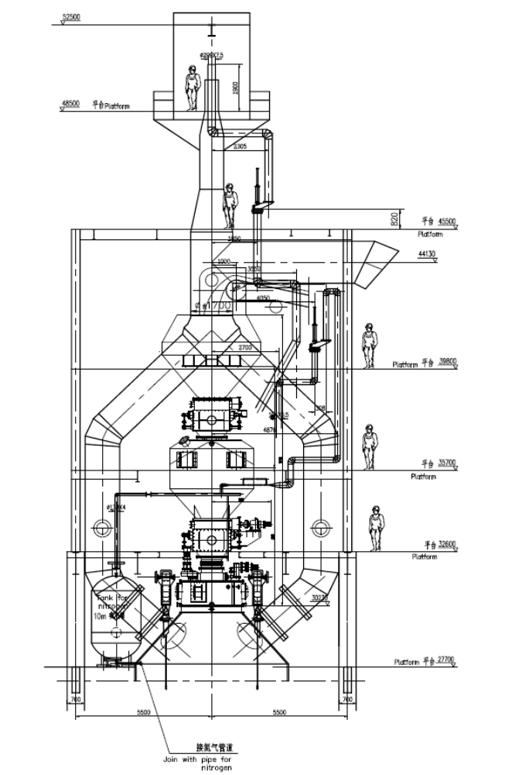 General Layout of BLT
Off-takes
Bleeders
Relief valve
Distributor
Upper seal valve
Burden Stop Valve
Receiving tank
Primary Equalising valve
Secondary Equalising valve
Burden tank
Lower seal valve
Burden flow regulating Valve
Left Stock rod
Right Stock rod
Down comer
Up-takes
Conveyor #1 discharge end
3.0 BF Proper System
BF proper system is composed of cooling members, cooling system, refractory, shell, structural support and auxiliary equipment. The BF proper is free-standing frame structure. The interval between frame braces is 11000 x 11000mm.
In order to ensure BF long campaign life, improve productivity, short and stout BF profile and longer campaign technology is used.

3.1 BF Profile
The reasonable profile is used to improve the melting and permeability of the burden and enhances the usage of BF gas chemical energy.
The BF will be provided with 14 tuyeres, 1 taphole and 1 slag notch.
No. | Item | Unit | Value
1 | Effective volume, Vu | m³ | 450
2 | Crucible diameter, d | mm | 5400
3 | Belly diameter, D | mm | 6300
4 | Throat diameter, d₁ | mm | 4400
5 | Old horse, h₀ | mm | 1035
6 | Tuyere height, h_{f} | mm | 2700
7 | Crucible height, h₁ | mm | 3100
8 | Bosh height, h₂ | mm | 2800
9 | Belly height, h₃ | mm | 1400
10 | Stack height, h₄ | mm | 10300
11 | Throat height, h₅ | mm | 1670
12 | Useful height, Hu | mm | 19270
13 | Angle of stack, β |  | 84°43′49″
14 | Angle of bosh, α |  | 80°52′11″
15 | Hu/D |  | 3.06
16 | Crucible section, A | m² | 22.9
17 | Vu/A |  | 19.65
18 | Tuyere | Pcs | 14
19 | Taphole | Pcs | 1
20 | Slag notch | Pcs | 1
3.2 BF Lining
The BF bottom will be lined with the semi-graphite self fluxed carbon blocks of high conductivity. The BF hearth and the taphole area are of mold pressing carbon bricks and then the ceramics cup technology of combined brown corundum will be adopted on the heating surface of bottom and hearth of the BF. The area of taphole and tuyere will be of compounded corundum bricks. In one side working layer of bosh, belly and stack will be lined with silicon carbide. For the upper part of the furnace where no cooling staves are there, unshaped refractory material of thickness ̴70mm will be painted in the furnace shell by guniting. The inner wall of the top cone will be lined with a layer of gunning refractory material.

3.3 Proper Cooling and Cooling Equipment
The BF proper will be cooled with open medium pressure industrial water. 4 sections of smooth cooling stave are adopted in furnace bottom and hearth, with single-in and single-out snake shaped seamless steel tube, the material of cooling stave is normal cast iron. Cooling stave encased with ribbed plate is adopted for bosh and belly, with two layer of single-in and single-out snake shaped seamless steel tube.
The middle and lower part of stack adopts "r" shaped mosaic structure of cooling staves which is capable to support the lining effectively.
The pore opened on shell are less in number for the installation of cooling stave, capable to protect furnace shell effectively and improve the tightness of BF against leakage of BFG.
The material of cooling stave for middle and lower part of stack, bosh and belly is spheroidal graphite cast iron.
2 section steel-clad brick is adopted for furnace throat. Water cooling pipe are provided for the cooling of furnace bottom.
Water spraying cooling device coupled with steam inlets will be installed on BF top in order to protect the top equipment.

3.4 Proper Cooling Water System
Two circulation cooling water systems will be adopted. The BF normal pressure industrial water will be double-loop open circulating cooling and the circulating water amount of normal pressure industrial is ̴1900t/h, among which the cooling water amount for hot blast stove valves is 360t/h, and the pressure of water supply point is 0.4 ̴ 0.6MPa. In case of the failure of one loop of water supply pipeline, the other one will supply 70% of water to ensure the running of the cooling equipments. The high pressure industrial water will be single-loop circulating cooling and the circulating water amount is ̴ 320t/h, and the pressure of water supply point is 1.0 MPa, which will be used for the cooling of tuyere and slag notch. In order to protect the tuyere and slag notch in case of the failure of the high pressure water pipeline, the high pressure water pipeline will be connected with the normal pressure water pipeline.

3.5 Proper Detection
In order to monitor the temperature distribution of the BF bottom, belly and stack, and the know the state of the burning loss of the refractory and cooling members in time, temperature measuring device are installed at the BF bottom, belly and the stack; instruments for the detection of flow, pressure and temperature are installed for the proper cooling system.

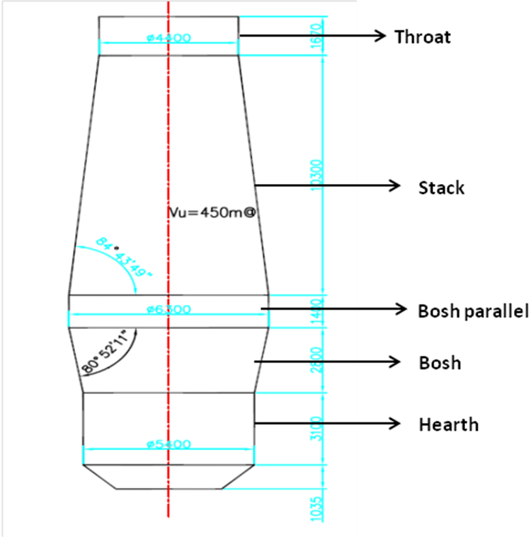
Internal Profile of BF

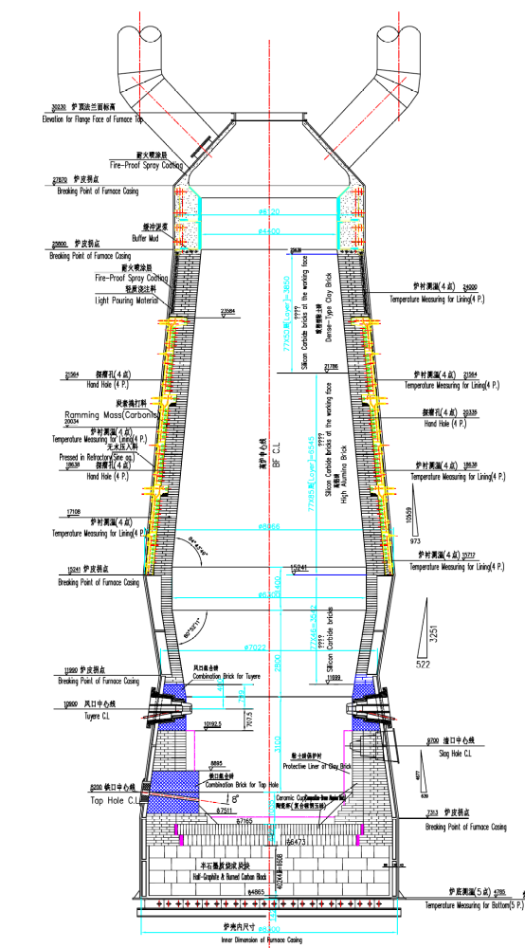
General View of BF Bricking
4.0 Tuyere Platform and Cast House
It is composed of tuyere platform and cast house system. 3T electric hoist in circular mono rail for Blow pipe and Tuyere handling is provided.

Description
The blast furnace is having one cast house and one tap hole. Three positions for 65t hot metal ladle is there in the cast house. One hook bridge type crane with span of 22m and capacity 16t is present for routine lifting and handling for furnace in the cast house.

4.1 Main Equipment on Tuyere Platform and Cast House
One set of KD100 type hydraulic clay gun with the total thrust force of 1130kN is installed in front of BF.
One set of KDIIA hydraulic taphole drill with drilling head diameter of ᴓ50-60mm is present and the maximum depth of the taphole is 2000mm. The mudgun and the taphole drill are installed at the same side of the taphole, and a fold type hydraulic slag stopper is present to hold the monkey.
4.2 Hot Metal Transportation
HM is transported with 65t HM ladle car and casted into pigs directly by the pig casting machine.
There is a winch operated trolleys for hot metal transportation. 4 nos. of transfer cars/trolleys, each carrying one ladle is present. Total number of ladles is 5.
Limit switches are provided at both the ends of the rail (Cast house side & PCM side) for safe positioning.
5.0 Hot Blast Stove
Hot blast stove system adopts 3 sets of peel top combustion stove. Hot blast stove adopts high efficiency 19 pore checker bricks and high porosity fire grate, the designed hot blast temperature is 1100ºC, maximum 1150ºC. Maximum dome temperature is 1300 ̴ 1400ºC. Hot air duct provides running piping adaptable to high temperature and capable to absorb expansion and strain. 2 sets of combustion fan are present of which one is working and the other one standby. Computer automatic control includes combustion control, input air temperature control and stove conversion control etc.

Basic Design Condition
Heating air rate: 1350Nm³/min
Cold air pressure: 0.28 MPa
Designed air temperature: 1100ºC
Designed dome temperature: 1300 ̴ 1400ºC
Calorific value of gas: ̴ 3344kJ/m³
Air input cycle: 45 ̴ 60 min
No. of hot blast stove: 3

5.1 Structure of Hot Blast Stove
i. Structure of Stove Stack
The peel top combustion stove is composed of peel burner, frustum combustion chamber and checker chamber. The burner is located at the top of hot blast stove, the gas and air injects from different angle with high speed into the mixing room of burner, fully mixed with combustion air under the rotational flow of gas, fully burning. Frustum combustion chamber is connected with checker chamber, and checker brick is lined inside the checker chamber. The burner and combustion bricking-up are separately supported by brick holder of stove shell. For this type of hot blast stove, the burner, combustion chamber and checker chamber is independent to each other, the structure is more stable. There is no partition wall between checker chamber and combustion chamber, therefore overcomes the disadvantage of the partition wall of conventional Cowper stove easily to become inclined and collapse, and not like external combustion stove having large investment and large land occupation.
In order to keep the integrality of the bricking-up, combined brick is adopted for the exit of hot air and the entrance of gas and air.

ii. Checker Chamber
The total height of inner checker brick column is 19.8m, from top to bottom, the bricks are as following:
- High alumina brick with high temperature resistance and low creep
- High alumina brick
- Low creep chamotte brick.
The type of checker brick is 19 pore 30 mm diameter new pattern checker brick, compared to conventional 7 pore checker brick, unit heating area is larger, therefore on condition that the quantity of checker brick is equal, the overall heating surface can increase approximately ̴15%. The heating surface increase brings great benefit for achieving high air temperature.

5.2 Refractory selection of Hot Blast Stove
- Hot Blast Stove Proper

The principal of refractory selection is based on the temperature distribution of different zones, to select reasonable refractory suitable for physical and chemical property of working condition, meanwhile in consideration of economy.

The high temperature zone of checker chamber of hot blast stove adopts high temperature low creep high alumina brick; the lower part has high alumina bricks and chamotte brick according to the temperature distribution. In order to protect hot blast stove shell and strengthen heat insulation and reduce heat losses, amorphous refractory is sprayed to the inner surface of hot blast stove. Heat insulation layers are reasonably arranged to strengthen thermal retardation and reduce heat losses.

Considering the feature of intense temperature variation during working of hot blast stove, temperature shock resistance cordierite - mullite brick is used for the inner wall of burner.

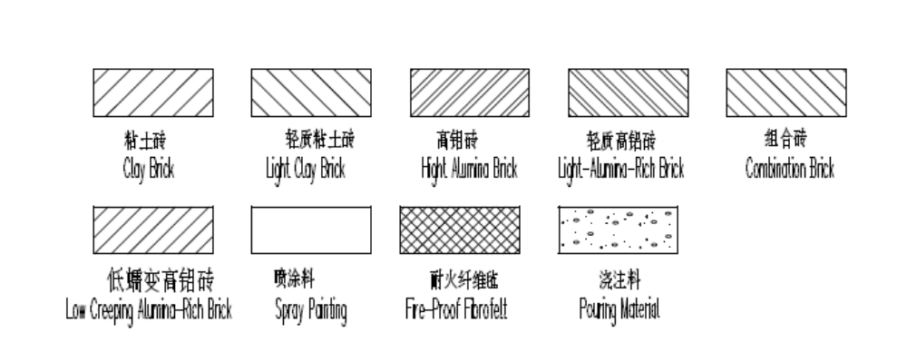
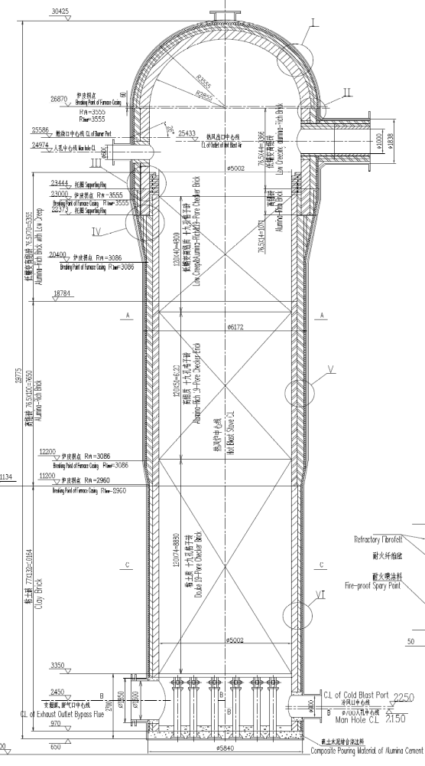
General View for bricking of the HOT BLAST STOVE
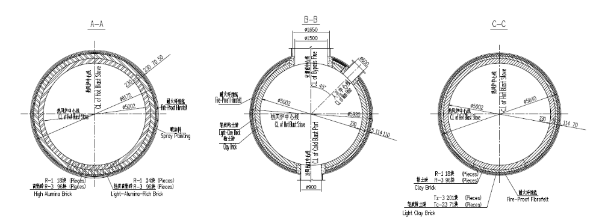
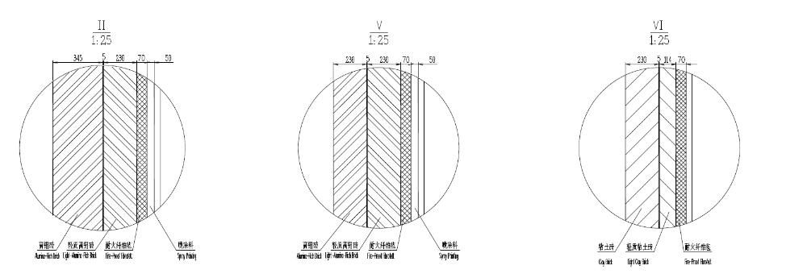

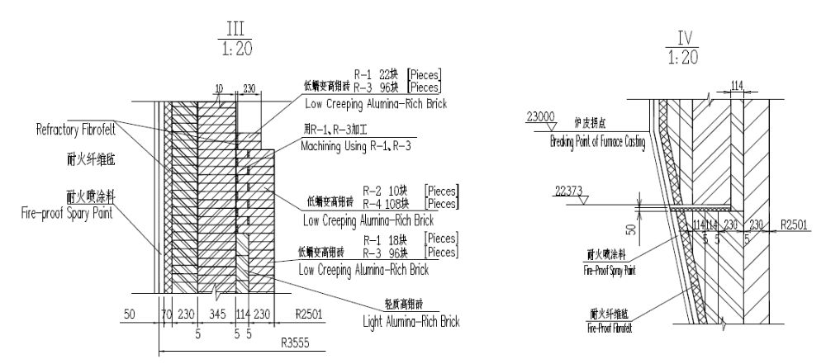

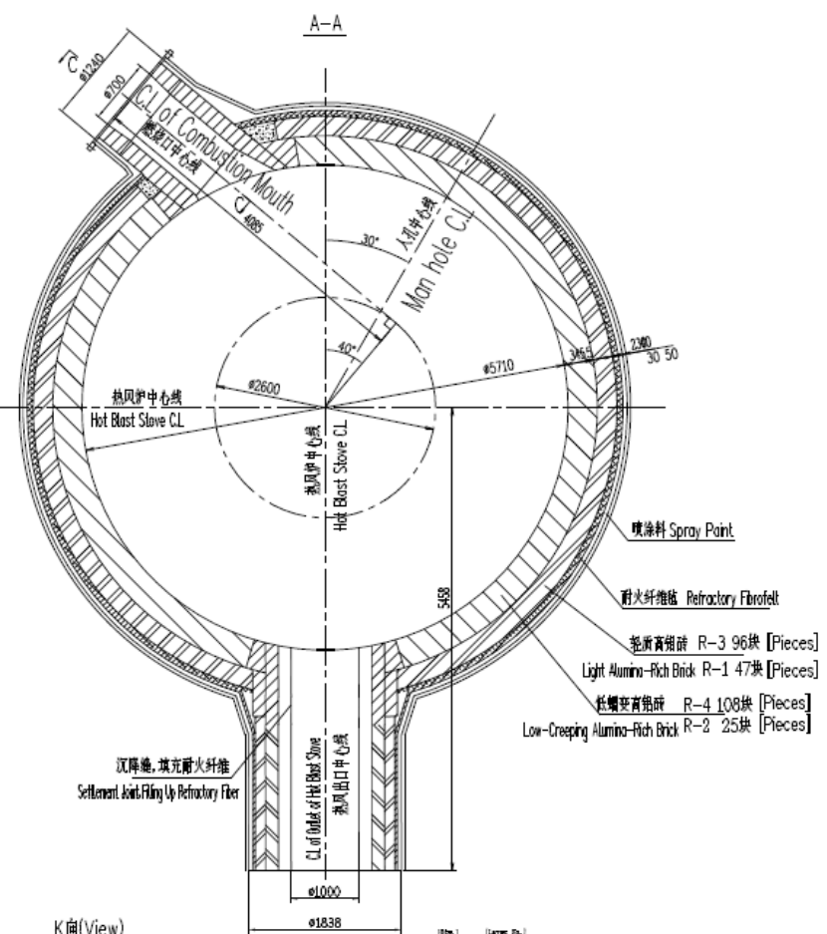

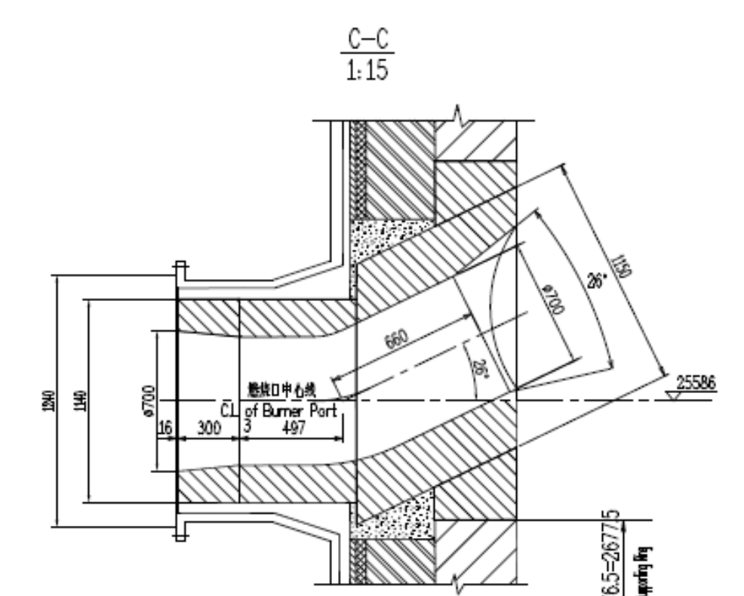

- Duct of Hot Blast Stove

Low creep high alumina brick is used for inner lining of hot blast stove duct, light high alumina brick and light spraying material are used as heat insulation layer.

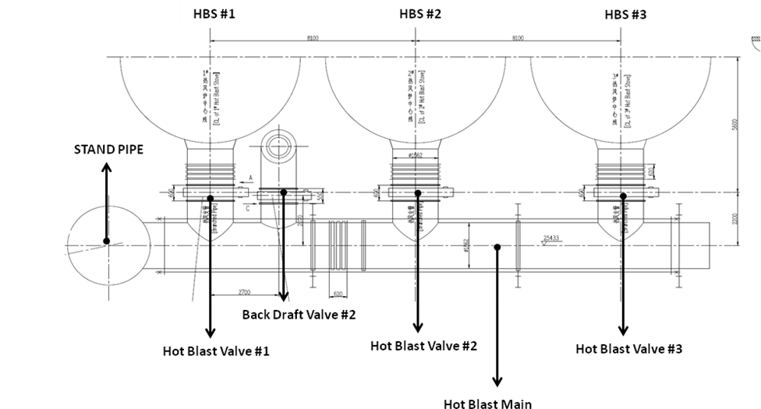

General view of Hot Blast System connecting all stoves and stand pipe at 24.3 mts elevation

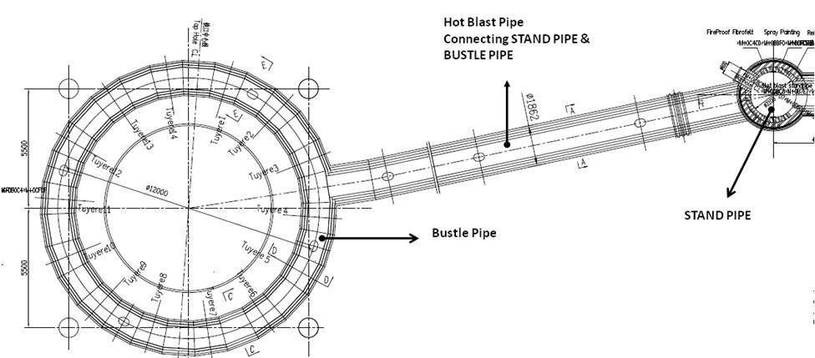

General view of Hot Blast System connecting stand pipe and Bustle pipe at 11.4 mts elevation

Fire Grate and Pillar
Cinquefoil shape fire grate is used which has high porosity. The material is low chrome heat resistant cast iron; its maximum bearing temperature is 400ºC.
Combustion Fan
2 set of centrifugal fan (1 working + 1 standby) as combustion fan is there to provide centralized supply of air for hot blast stove through the air preheater which heats the combustion air to ̴130⁰C and is installed on the main pipe of hot blast stove flue duct. The air rate of CA fan is 50995m³/h, full pressure is 14.488 kPa, motor power 315 kW, 11kV HV motor. Regulation valve and silencer is provided at the inlet scoop.

Gravity Dust Catcher System
Gravity dust catcher system consists of gas delivery tube, uptakes, downcomer, body of gravity dust catcher (8000mm dia.), GDC isolation valve, bleeding valve, Main humidifying ash unloader etc.
Raw gas comes out by four delivery tubes, which converges into two off takes, and finally converges into one downcomer which enters into gravity dust catcher. After primary dedusting of the gravity dustcatcher, the dust content of the gas is about 6 ̴ 12 g/m³. The gas ash in the gravity dustcatcher is discharged periodically through the ash discharging machine and ash removal tube on the lower part of the gravity dust catcher.
Two bleeding valves will be provided on the top of the gas uptakes.
One furnace isolation valve and two 550mm dia. bleed valves for gas is there on top of the gravity dust catcher.

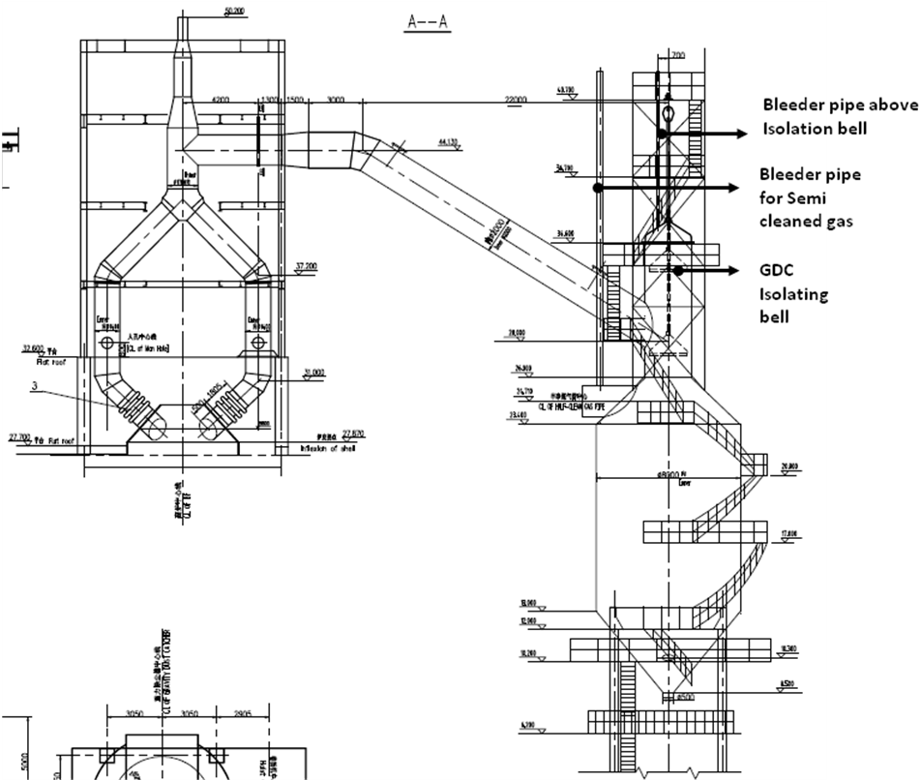
General Drawing of Crude Gas System

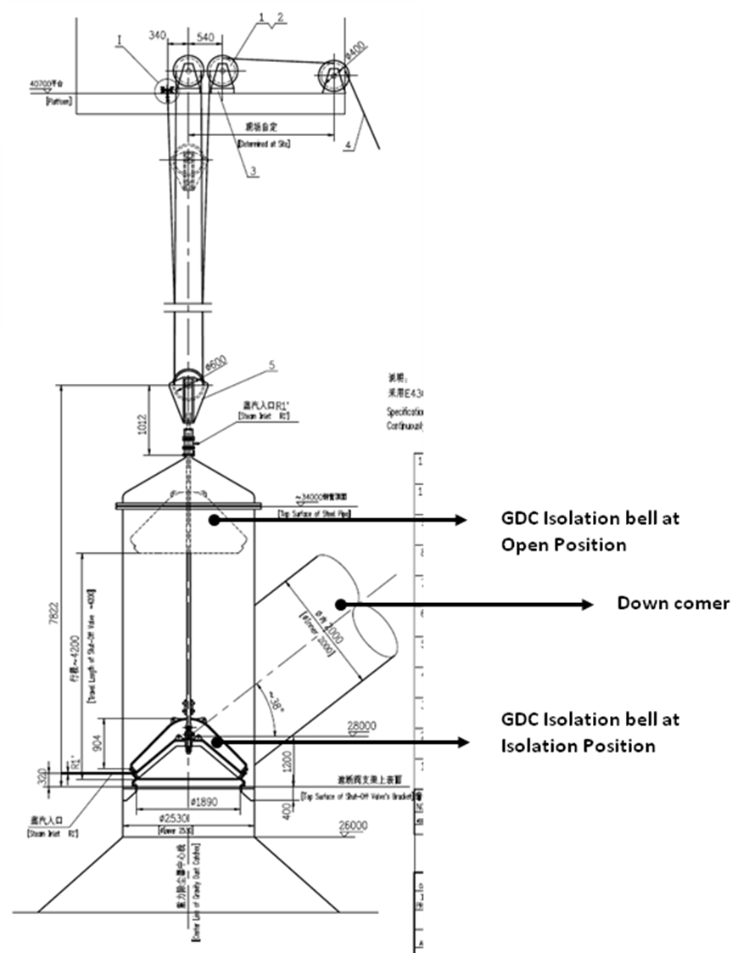
GDC Isolation valve arrangement

Pig casting machine
In order to satisfy the requirements of BF iron casting, one set of 60m double-chain roller pig casting machine is there. The capacity of PCM is ̴ 200t/h. There is a 100/20t EOT crane which is used to tilting and pouring of hot metal ladles and also for placing the ladles on the hydraulic tilter. Hydraulic tilter tilts and pours the hot metal ladles on to the PCM. Pig iron blocks produced are then directly loaded on the trucks through diverting chute mechanism that is pneumatically operated.
BF slag treatment system
BF slag granulation system has full bottom filtering method to produce granulated slag. It consists of a water tank with 3 compartments. These compartments are separated by sluice fitted on top which filters the water and provides it to the last tank from where it is sucked by the 3 slag granulation pumps for recirculation. Only 1 pump runs at a time, rest 2 are in standby.
One set of 10t gantry grab crane is used to grab slag from the filter tanks and dump it into the trucks for transporting it to the slag yard. The span of crane is 18m.

BF Blower Station
The blast furnace is provided with two sets of D1650 electrical centrifugal blower, one working and one standby. Maximum air volume delivered is 1650Nm³/min (99000Nm³/hr); outlet pressure is 0.35MPa and rated power of motor is 5600kW.
Blower system is provided with condition monitoring facility like vibration, temperature and current.
The blower house is also provided with an overhead crane of capacity 32/5t for maintenance of blowers etc.
The inlet suction of air is filtered with the help of an air filter group which consists of multiple high efficiency filter bags. The capacity of the suction filter is 4000m³/min X 2 = 8000m³/min. The dust content in the air after filter is <0.5 mg/m³; grain size of dust is less than 2.0 microns; filtering efficiency is 99.9%.

Correction Factors of Local Climatic Condition
Season | Atmosphere  Temperature℃ | Atmosphere  Pressure  mmHg | Relative  Humidity  % | Delivery Correction Factor （k）
Summer | 38 | 756 | 90 | 0.805
Winter | 25 | 760 | 63.5 | 0.888
Annual Average | 31.5 | 757 | 82 | 0.849

Performance Figure Table of BF Air Blower
No. | Description | A | B | C | D | E
1 | Inlet Air Flow in Standard State Nm³/min | 1323 | 1228.5 | 1039.5 | 1228.5 | 1228.5
2 | Inlet Air Flow in Suction State m³/min | 1643.5 | 1526.1 | 1181.25 | 1396.0 | 1447
3 | Inlet Temperature(⁰C) | 38 | 38 | 25 | 25 | 31.5
4 | Exhaust Pressure MPa (A) | 0.342 | 0.253 | 0.253 | 0.343 | 0.343

Compressor House
The total compressed air consumption for BF & SP is 40m³/min at a pressure of 0.4-0.6 MPa. So to fulfil this requirement there are 3 sets of water cooling screw type air compressors provided, 2 in use and 1 standby. Capacity of each compressor is 24m³/min at 0.8 MPa. There are 3 sets of micro-heat regeneration driers to dry the compressed air, 2 in use and 1 standby. Capacity of each drier is 31.28m³/min at 0.8 MPa.
Compressed air consumption for coal injection is 20m³/min at a pressure of 0.5～0.8Mpa, therefore 2 sets of water cooling screw type air compressors are provided, 1 use and 1 stand-by; capacity of each one is 24m³/min at a pressure of 0.8 MPa. Another 2 sets of micro-heat regeneration driers are there to dry the compressed air, 1 use and 1 stand-by, capacity of each one is 31.28m³/min at a pressure of 0.8 MPa.
Two air receiver of volume 6 m³ is present outside the station to maintain the pressure in the line during compressor unloading.. Electric hoist is there for the maintenance of the compressors.
Water Supply and Drainage Facilities
The plant is provided with perfect water supply and drainage system. There are production water line; fire fighting line and domestic water line. A fresh water reservoir of capacity 2500 m³ is present to cater the needs of production line and fire fighting line. 2 tanks of 10000 litres each are installed for domestic purpose. There are 3 pumps connected to the fresh water reservoir which pumps the water to both BF and sinter plant. The domestic line has got two separate pumps.
The sewage and rain water is drained by combined drainage system. Sewage drainage is 8m³/h, which is drained to drainage pipe network. Rainwater is collected by the ducts and drained to the drainage pipe network.
Total water consumption of iron making area is 4388m³/h, of which, the clean water circulating capacity is 2493m³/h, dirty water circulating capacity is 1750m³/h, fresh water for production is 145m³/h.
The entire water system circulating ratio is 96.6%. The domestic water consumption is 10m³/h.

Water Supply and Drainage System
According to the requirement of water quality, water pressure, water temperature of production process, following water supply and drainage system is present:
- Clean water circulation system for BF cooling.
- Pig casting machine dirty circulation water system.
- Dirty water circulation system of water rinsing slag for BF.
- Water supply system for production and domestic water and fire fighting.
- Sewage and rainwater drainage system.

Clean Water Circulation System for BF Cooling

- High Pressure Clean Circulation Water Supply System for BF Cooling

The system is mainly used to supply cooling water to tuyere and slag notch of BF, the cooling water supply capacity is 320m³/h, working pressure is 1.2MPa, water supply temperature is 35℃, return water temperature is 40℃, the water supply working system is continuous.

After being used, the cooling water is at a higher temperature, and the water quality is not polluted. The return cooling water is collected to complex water circulation pump station and hot water suction well via pipeline and BF proper, hot blast stove, and boosted to the cooling tower for cooling via pumps. Later on, water is boosted via two high pressure water pumps (1 in use and 1 standby) and delivered to the consumer for circulating use through pipeline filter which filters the water partially.

- Medium Pressure Clean Circulation Water Supply System for BF Cooling

The system is mainly used to provide cooling water to BF proper, hot blast stove, water supply capacity is 1900m³/h, working pressure is 0.6MPa, water supply temperature is 32℃, and water return temperature is 36℃, the water supply working system is continuous.

After being used, the cooling water is at a higher temperature, and the water quality is not polluted. The return cooling water is collected to complex water circulation pump station and hot water suction well via pipeline and BF proper, hot blast stove, and boosted to the cooling tower for cooling via pump. Later on, water is boosted via 3 medium pressure water pumps (2 in use and 1 standby) and delivery to the consumer for circulating use through pipeline filter which filters the water partially.

- Low Pressure Clean Circulation Water Supply System

The system is mainly used to provide cooling water to air blower station, air compression station, water supply capacity is 273m³/h (the air blower machine and air compression machine maybe work at the same time for a short time, in this case, the spare water pump will run, then the water supply capacity will be 500m³/h to satisfy the water requirement of consumer), working pressure is 0.4MPa, water supply temperature is 32℃, return water temperature is 37℃, continuous water supply working system.

This system return cooling water is pressed up to cooling tower taking advantage of overpressure. After boosted to the cooling tower and lowering the temperature, flow to cold water suction well of complex water circulation pump house, and will be boosted via 2 low pressure water pumps (1 in use and 1 standby) and delivery to the consumer for circulating use through pipeline filter which filters the water partially.

Dirty water Circulation system
Pig Casting Machine Dirty Circulation water supply
The system is mainly used to provide cooling water to pig casting machine, ingot pit spray. The water supply capacity is 350m³/h and working pressure is 0.3MPa. It is an incontinuous working system.
Cooled water flows to horizontal flow settling tank, after settling down, the clarified water flows to suction well of water circulation pump house for circulating use after boosted by two PCM pumps (1 in use and 1 in standby).

Dirty Water Circulation System of Water Rinsing Slag of BF
The system mainly supplies water for rinsing BF slag. The water consumption is 1400m³/h, and working pressure is 0.4MPa. It is a continuous working system.
The used water flows to horizontal flow settling tank, after settling down, the clarified water flows to the suction well of water circulation pump house for circulating use after boosted by three slag granulation pumps (1 in use and 2 in standby).

Emergency Water Supply System
- 2 circuits individual power supply is provided to water supply pump of each water circulation pump station.
- Standby pump is provided to each water supply pump units. Automatic switch over device is provided to working pump and standby pump. In case the working pump trips, the standby pump is put into operation automatically.
- 1 set of emergency diesel engine water supply pump is provided to cooling water supply pump units of BF proper, hot blast stove. The diesel storage capacity of the tank is 900 liters and the consumption of diesel is 1litres/hour when running on full swing.
- Double cooling water supply pipeline is present in BF proper and hot blast stove. The water supply capacity of single pipeline will take 70% of the total water supply amount.
- An Emergency safety tower of 500m³ is built to supply water to the important cooling members of BF and hot blast stoves. In a normal condition this amount of water can last for 15 minutes. This water is used only when the diesel pump is not working or the cold well level is below 3 meters.

Water Stabilization Measurement
In order to ensure long term and stable running of BF clean circulation cooling water system, dosing device is provided for water quality stabilizing, which doses the water with stabilizing drugs such as various inhibitor, anti-scale agent and algaecide etc. This maintains the pH of water in the range of 7-8 and prevents the cooling staves from premature failure.

Structures and Equipment of Water Supply and Drainage

Structures of water supply and drainage facilities are as following:
- Complex water circulation pump house.
- Water circulation pump house for pig casting machine.
- Water circulation pump house for water rinsing slag.
- 500m³ safety water tower.
- Water reservoir of capacity 2500m³ and fresh water pump station
Complex Water Circulation Pump Station

The pump station consists of water pump house, dosing room, power distribution operation room, water pump suction well and cooling tower.
Water pump house is ground type, 45m long, 12m wide, and total floor area is 45x12m.
4 groups of water supply pumps will be provided in the water pump house, totally 11 sets (with mechanical seals), of which, 1 set is emergency diesel engine water supply pump, 3 sets self cleaning filters, 1 set water stabilization dosing devices and 1 set of float activated submersible pump for ground water drainage.
4 sets of 700m³/h and 2 set of 300m³/h cooling towers is present on the top of water pump suction well.

Water Circulation Pump Station for Pig Casting Machine

The station consists of water pump house, operation room, water pump suction well, horizontal flow settling tank.
Water pump house is underground type, underground part is -4.5m , 19m long, 9m wide, provide with 2 groups of water pumps, of which, 1 group (2 set ) is water supply pumps ,another group (1 set) is ground drainage pump (float activated submersible pump).
Totally 2 compartments in the horizontal flow settling tank, each 20m long, 4.8m wide is present. The railway surface elevation of crane is 9.5m. 1 set of single girder crane for grasping sediment is present with lifting capacity of 3t and grab volume of 0.5m³.

Water Circulation Pump Station for Water Rinsing Slag

The station consists of water pump house and operation room.
Water pump house is underground type, underground part is -4.0m, overground part is +4.5m, 18m long, 7.5m wide.
2 groups water pumps will be provided in the water pump house, totally 4 sets, of which, 1 group(3 set ) is water supply pump i.e. slag granulation pumps, another set is ground drainage pump i.e. submersible pump.
Water Reservoir of Capacity 2500m³ and Fresh Water Pump Station

The pump station consists of water pump house, operation room and water reservoir. The water pump house and operation room is 15m long and 6m wide.
Water pump house is underground type, underground part is -2.5m, overground part is 4.5m.

1set of variable frequency driven (VFD) water supply pump is present in the house, consisting of:
Matched water pump: SLS150-400, 3 sets (2 sets work, 1 set standby), capacity of water supply is 200m³/h, the pressure of pump is 50m, and the power is 45KW.
Matched air pressure pot: ML1000x1.0 1 set
Matched accessory:
Special frequency conversion control cabinet 1 set
Inlet/Outlet valves, pressure meter, releasing pressure valve and etc
Totally 2 compartments in the water reservoir, each 27m long, 7.5m wide concrete structure is present.

Pipeline Laying and Material
Pipeline Laying
Open laying and direct embedded laying modes is used to indoor and outdoor water supply and drainage pipeline.

Material of Pipeline
Indoor and outdoor water supply pipeline for domestic, production, fire fighting is of rigid polyvinyl chloride pipe and welded steel pipe. Welded steel pipe and spiral seam welded tube is used in water circulation pipeline. Water drainage pipeline are of rigid polyvinyl chloride pipe, water drainage pig casting pipe and RC drainage pipe.

Economic Technical Index
Total production water consumption 4388 m³/h
Including:
Clean water circulation capacity 2493 m³/h
Dirty water circulation capacity 1750 m³/h
Fresh water capacity for production 145 m³/h
Circulating ratio 96.6％
Repeat utility ratio 100％
Domestic water consumption 10 m³/h
Domestic water drainage 8 m³/h
Total installed capacity 2612.9kW
Working capacity 1872.18kW
Power consumption of circulating water 0.43kW.h/m³-water

Combustion Gas Facility
Dry Bag De-dusting System for 450m³ BF Gas
Design Condition
Blast Furnace Capacity: 450m³
Pressure of Blast Furnace Top: Max: 0.15MPa
Normal: 0.03MPa
Gas Generating Capacity: Average: 100000Nm³/h
Max: 120000Nm³/h
Gas Temperature: Normal 100~250℃
Max: 400℃ (short time)
Dust Content of Inlet Gas: ≤10g/Nm³
Dust Content of Clean Gas: ≤10mg/Nm³

De-dusting Flow Chart of Bag Filter

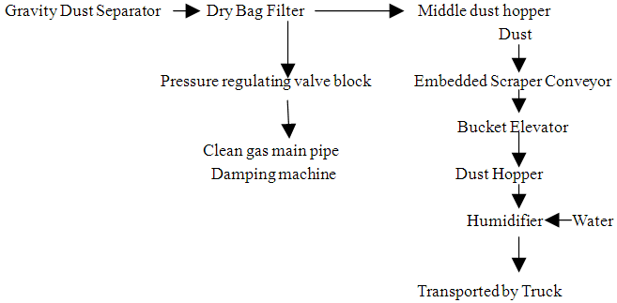
BF Gas Dry Bag Filter
The Dry Bag Filter of 450m³ blast furnace adopts 8 boxes, inner diameter is 4000mm and height is 15000m. 7 boxes is used at normal condition. To ensure the effect of BF gas de-dusting, 1 box is cleaned or overhauled or standby.
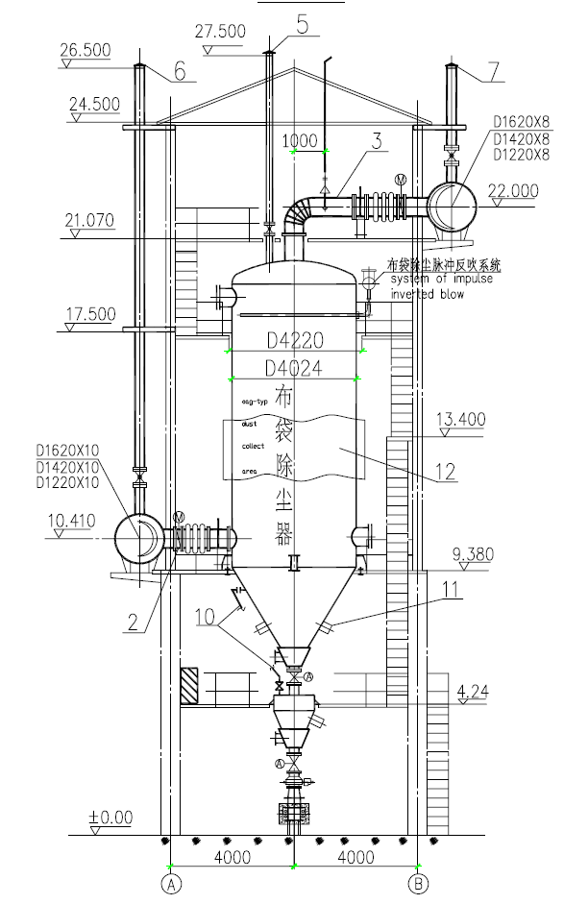
Layout of Bag Filter System
The bag filter system is a single row.

BF Gas Exhaust Device
In order to ensure the pressure stabilization of BF and BF gas pipeline, and protect environment, the residual BF gas should be fired and exhausted, therefore one set of DN1000mm exhaust device will be provided.

Facility of Oxygen and Nitrogen Gas

Table of Oxygen Consumption

Sr. No. | Consumer | Oxygen Consumption m³/h |  | Working Pressure (MPa) | Working System
Sr. No. | Consumer | Average | Max | Working Pressure (MPa) | Working System
1 | BF
i | BF Enriched Oxygen Blast | 3000 |  | 0.4~0.6 | Continuous
ii | Interval Used Oxygen Before Furnace | 180 |  | 0.4~0.6 | Interval
2 | Lose 3% | 100
 | total | 3280

Table of Nitrogen Gas Consumption

Sr. No | Consumer | Nitrogen Gas Consumption m³/h |  | Working Pressure (MPa) | Working System
Sr. No | Consumer | Average | Max | Working Pressure (MPa) | Working System
1 | Nitrogen Used for Gear Sealing at BF Top | 200 | 900 | 0.4~0.7 | Interval
2 | Nitrogen Used for Pressure Balance at BF Top | 250 |  |  | Interval
3 | Nitrogen for PCI of BF
i | Pressure Filling of Coal Injection Tank | 108 | 144 | 0.6~0.8 | Interval
ii | Makeup Gas for Fluidization of Coal Injection Tank | 240 | 320 | 0.6~0.8 | Interval
iii | Fluidization of Coal Pulverized Coal Bin | 100 | 150 | 0.6~0.8 | Interval
iv | Nitrogen Filling of Coal Grinding Machine |  | 1200 | 0.6~0.8 | Interval, accident
4 | Nitrogen for back purging of BF Gas | 500 | 720 | 0.4~0.8 | Interval
5 | Gas Consumption for Sintering | 900 | 1000 | 0.4~0.8 | interval
 | Loss 3% | 100 | 100
 | Total | 2398 | 4534

According to the production requirement, there are two pipelines of ф219X6 from outside of factory to BF area, one for oxygen and one for nitrogen gas. There are regulation devices of oxygen and nitrogen gas present to regulate the pressure and flow of the gases as per requirement.
Dedusting System for Raw Material Bin and Transfer Station
Design description
The raw material bin dedusting will mainly serve for exhausting and dedusting dust produced when raw material are discharged into received bin. Air rate: 12000m³/h.
The transfer station dedusting will be designed for exhausting dust from ore and coke discharging from belts. There will be three transfer stations, and air rate for each station is 12000m3/h.
The distance between transfer stations are too long, so one set of packaged flat cloth bag filter is designed for everyone.

The Process Flow
Dedusting collecting point →valve→ duct→ bag filter→ fan →outside
→hopper of deduster→ truck
Specification of Main Equipment
Packaged flat cloth bag filter: 4 Set
Equipped exhaust fan type: 4-72-12NO.5 4 set
Air volume per set: 12128m³/h
Air pressure (γ=0.875kg/m³): 2792 Pa
Rotating speed: 2900 rpm
Equipped motor: Y160M2 N=15Kw
Voltage: 380v
Emission concentration ≤50mg/Nm³

Pulverized Coal Injection System

The oxygen enrichment along with coal injection is capable of using coal instead of coke, with the benefit of saving coke and improving BF condition.

Raw Coal Storage and Transportation

Raw coal is transported by truck to the coal storage yard, and then transported to the coal receiving hopper by the front-end loader, afterwards conveyed to the coal storage bin through the large-inclination-angle belt conveyer, then to the middle-speed grinder.

Pulverized Coal Injection Process
The method of injection adopts parallel injection tank, single-tube injection and distributor in front of the Blast furnace, and dense phase transportation technology (the concentration of pulverized coal is 40-60kg/kg of compressed air, compressed air source pressure is 0.8MPa.)
The injection system consists of pulverized coal bin, coal injection tank, main injection tube, mixer, pulverized coal distributor and injection lance.

The process flow chart of the pulverized coal injection system:

Pulverized coal transportation pipe → pulverized coal bin → injection tank → main injection tube → pulverized coal distributor → injection branch tube → injection lance → tuyere → BF.

In order to ensure the safety and the reliability of the injection bituminous coal, a series of fire-proof and anti-explosion measurements is adopted, such as: the system is wholly grounded for eliminating the static electricity; the injection tank is provided with detecting instrument for temperature, pressure, etc. and emergency nitrogen filling protection, etc.

Pulverized Coal Injection Capacity

Normal coal injection: 120 kg/thm
Equipment capacity: 120 kg/thm
PCI mill capacity: 15t/h
Accuracy of injection rate: ±5%
Fineness of pulverized coal: 70% (200 mesh)
Final surface moisture: 2 %

Online magnetic separator is present before the mill.

Other Facilities of PCI System

Raw Coal
Raw coal bin capacity: 90m³
Level measurement: load cells
Feeding arrangement to raw coal bin: belt conveyor
Belt width: 800mm
Capacity of conveyor: 50t/h

Fine Coal
Fine coal bin capacity: 90m³
Level measurement: load cells

Hot Gas Generator
No. of unit: one
Capacity: 34860Nm³/h
Heating fuel: BF gas
Supplementary fuel in emergency: (HSD)

Suction Fan (boost Hot Blast stove waste gas)
Capacity: 40800m³/h
Combustion air fan: one (2536m³/h)

Bag Filter for Pulverized Coal
Type: impulse jet type
Bag material: anti static polyester needle felt
Smoke Exhaust fan: one (43817 m³/h)

Injection System
No. of injection vessel: two
Capacity of each vessel: 18 m³
Measuring system: load cells
No. of distributor: one (No. of outlets is 14)
Conveying media: Compressed air
Type of CO detector: online
Type of O2 detector: online

